AN ANALYSIS OF STUDENTS’ SPEAKING ANXIETY

(A Descriptive Research to the Second Semester Students of English Education Study Program at IKIP PGRI Pontianak in the Academic Year of 2021/2022)

A THESIS

By:

CHRISTIANA METHA
NIM. 321810201

English Education Study Program

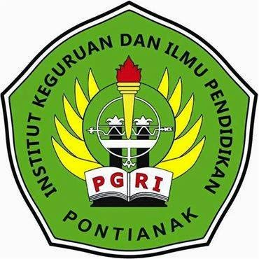

LANGUAGE AND ART EDUCATION FACULTY
INSTITUTE OF TEACHER TRAINING AND EDUCATION
TEACHER ASSOCIATION OF THE REPUBLIC OF INDONESIA
(IKIP-PGRI) PONTIANAK
2022

